Design Options

# Resources/DO%201/Window%203.pngResources/DO%201/Window%202.pngResources/DO%201/Window%201.pngResources/DO%201/Referencing%20Table.pngResources/DO%201/Export%20Screen.pngResources/DO%201/Browser.pngDesign Option 1

# Resources/DO%202/Window%202.pngResources/DO%202/Window%201.pngResources/DO%202/Referencing%20Table.pngResources/DO%202/Browser.pngDesign Option 2

# Resources/DO%203/Browser.pngResources/DO%203/Referencing%20Table.pngResources/DO%203/Window%201.pngResources/DO%203/Window%202.pngResources/DO%203/Window%203.pngDesign Option 3

# Design Option Criteria

**Design Option 3**

|  |  |
| --- | --- |
| **Pros** | **Cons** |
| Colour pallet | Redundant features |
| Easy to understand | Missing key features |
| Concise |  |

**Design Option 2**

|  |  |
| --- | --- |
| **Pros** | **Cons** |
| Colour pallet | Hard to understand |
|  | Blocky |

**Design Option 1**

|  |  |
| --- | --- |
| **Pros** | **Cons** |
| *Effective* | *Blocky* |
| *Fast* | *Hard to understand* |
| *Concise* | *Colour pallet* |

|  |  |  |  |
| --- | --- | --- | --- |
| Criteria | Design Option 1 | Design Option 2 | Design Option 3 |
| Speed of Operation | 7 / 10 | 8 / 10 | 9 / 10 |
| Ease of Use | 7 / 10 | 7 / 10 | 10 / 10 |
| Readability | 3 / 5 | 3 / 5 | 4 / 5 |
| Attractiveness | 3 / 5 | 4 / 5 | 5 / 5 |
| Accessibility | 3 / 5 | 4 / 5 | 4 / 5 |
| Usability | 3 / 5 | 2 / 5 | 4 / 5 |
| Total | 26 / 40 | 28 / 40 | 36 / 40 |

Design Option Criteria Table

## Comments // Continuance of Design – Reasons

I have decided to redo the design due to the feedback I’ve received from features of the past designs. I believe I can design a solution that will be able to score higher than the current highest scorer (36/40), and be able to produce a more effective solution.

## Written Descriptions

### Design Option 1:

This design has a large emphasis on ease of use, simplicity and monochromatic colour pallets.

I chose this because I wanted this design to be as clean and simple as possible, with design constraints coming from older versions of Windows. The reason for this is because I wanted the user to feel a sense of familiarity when opening and using the program

### Design Option 2:

This design borrowed features heavily from Design Option 1 and Design Option 2. Here, I tried to merge the two designs, combining the colour pallet, Flat UI design and emphasis on ease of use. The users that gave me feedback on this design alerted me that this didn’t come though as planned.

### Design Option 3:

Design Option 3 was heavily influenced on the Flat UI movement – which is another take on simplicity. Here, I tried to make the solution as simple as possible, whistle not sacrificing crucial features that the solution needs to be effective, like a large web browser, and readable and reliable referencing table.

Although this design has a much larger range of functionality windows, it makes the workflow easier, as users don’t have to think about what they are needing to do in each window – rather, its more spelled out for them with a step by step workflow. I decided this was needed through the answer I received on a survey, alluding that High School students may not fully understand how to reference, and need a more user-friendly workflow to help teach them.

# Resources/Images-UXPin-Design_Option__4%20Preferred%20Option%20-Export/Browser.pngResources/Images-UXPin-Design_Option__4%20Preferred%20Option%20-Export/Window%203.pngResources/Images-UXPin-Design_Option__4%20Preferred%20Option%20-Export/Window%202.pngResources/Images-UXPin-Design_Option__4%20Preferred%20Option%20-Export/Window%201.pngRemodelled Design

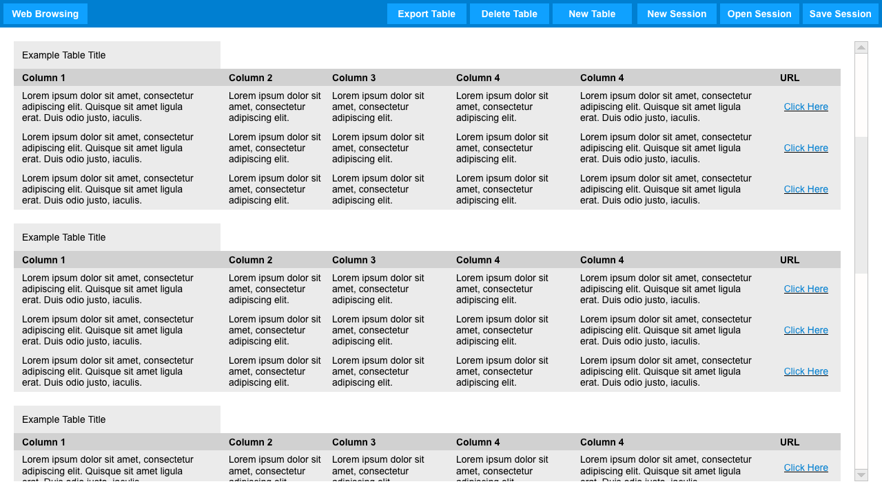

## Remodelled Design Score

## Remodelled Design Reflection

I am glad I made these changes – they have proven to make the solution a better option than previous options. Although it didn’t score the perfect score, I am able to live with this. I believe this allows for further improvement later on; it allows for user feedback and innovation.

## Remodelled Design Written Description

This design, coming with the best score (of 39.5 out of 40) gives the user the best UX out of all the designs.

The easy workflow assures the user a quality experience, while allowing a fluid use of the solution.

While being easy to use, the solution lacks no functionality; but rather borrows heavily from the layout design from Design Option 3. DO3’s sequence of events helps to encourage the user to learn how referencing is correctly applied to projects, case studies and reports. This helps accommodate for a wide range of user with different past experience with referencing, whether it be a lot, or none at all.

|  |  |
| --- | --- |
| Criteria | Design Option 1 |
| Speed of Operation | 10 / 10 |
| Ease of Use | 10 / 10 |
| Readability | 4.5 / 5 |
| Attractiveness | 5 / 5 |
| Accessibility | 5 / 5 |
| Usability | 5 / 5 |
| Total | 39.5 / 40 |

Remodelled Design Score